 |  |  | DATA SHEETS |  |  |  |  |  | No. | I-FD-3010.2G-5330-540-DTG-302
 |  |  | CLIENT: |  | E & P |  |  |  |  |  |  |  | SHEET |  | 1 |  |  | of | 41
 |  |  | JOB: |  | BUZIOS FIELD AREA DEVELOPMENT
 |  |  | AREA: |  | PETROBRAS 78 (P-78)
SRGE |  |  | TITLE: |  | EQUIPMENT DATA SHEETS - OILYWATER |  |  |  |  |  |  |  | ( I )
  SEPARATOR PACKAGE
 |  |  |  |  |  |  |  |  |  |  |  |  | SCP78
Keppel Shipyard / Hyundai Heavy Industries  CONTRACTOR Nº |  |  |  |  |  |  |  | 5900.0117818.21.2
DTG
INITIALS:
CREA Nº:
[File: MICROSOFT WORD/V.2003/I-AA-3010.2G-NNNN-NNN-KES-NNN_N ]  TECH.RESP.::  : |  |  |  |  |  |  |  | Shravan Kamat |  |  |  | - |  |  |  | -
INDEX OF REVISIONS
REV. | DESCRIPTION AND/OR REVISED SHEETS
0 | FOR DESIGN
 |  | REV. 0 |  | REV. A |  | REV. B | REV. C |  | REV. D |  | REV. E | REV. F |  | REV. G |  |  | REV. H
DATE |  | 18/10/2021
DESIGN |  | DLG
EXECUTION |  | DLG
CHECK |  | DLG
APPROVAL |  | -
INFORMATION IN THIS DOCUMENT IS PROPERTY OF PETROBRAS, BEING PROHIBITED OUTSIDE OF THEIR PURPOSE
FORM OWNED TO PETROBRAS N-0381 REV. L

INDEX
1. INTRODUCTION 3
2. MAIN COMPONENTS 4

INTRODUCTION
Petrobras (Client) has launched a tender to supply a floating production, storage and offloading vessel (FPSO) with a topside crude oil process plant and gas process plant for field development in the Buzios field in the Santos Basin. The FPSO, referred to as P-78, will have the capacity to process 180,000 barrels of oil and 7.2 million m3 of gas daily.

Keppel Shipyard Limited (“KSL”), a subsidiary wholly owned by Keppel Offshore & Marine Limited has the expertise in the whole spectrum of repair, conversion and building of a diverse range of vessels of different capacities. KSL has extensive experience in the conversion/new build of Floating Production Storage and Offloading (FPSO) vessels, Floating Storage and Offloading (FSO) vessels.

The Scope of Work shall be executed under an EPC Contract between Client and Keppel Shipyard Limited who shall be taking complete contractual responsibility for the full scope of Work as described in the Contract Exhibits.

The Work shall be carried out in accordance to the requirements of Client’s specification. This preliminary Project Execution Plan summarizes the intended execution method for the engineering, procurement, construction and commissioning onshore and offshore for the FPSO

< Figure 1-1: View of P-78 FPSO with modules >
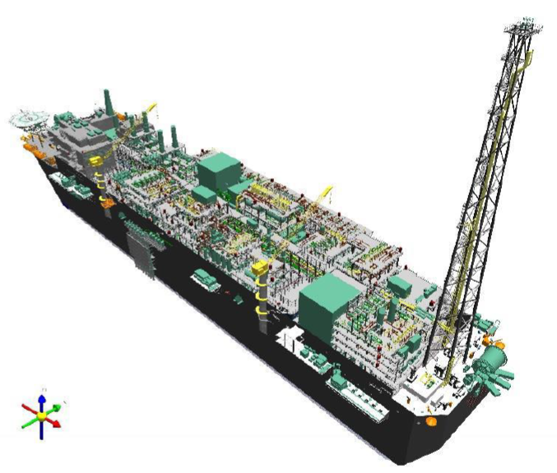

MAIN COMPONENTS

